

<BTS Website>

Project Report

DT282

Computer Science

**<Erifeoluwa Jamgbadi>**

School of Computing

Dublin Institute of Technology

**<6th December 2018>**



Declaration

I hereby declare that the work described in this dissertation is, except where otherwise stated, entirely my own work and has not been submitted as an exercise for a degree at this or any other university.

Signed:

__________Erifeoluwa Jamgbadi_______________

<Student Name>

<6th December 2018 >

Table of Contents

*1.* Problem Description 4

*2.* Research 4

*3.* Technology Selection and Site Architecture 4

*4.* Low Fidelity Prototype 5

*5.* Development Plan 6

*6.* Testing Plan 6

*7.* Site Evaluation 6

*8.* Deployment 7

Appendices 8

# Problem Description

My website is about BTS. BTS is a Korean boyband and I did this website because when I was starting into the Korean Scene, I had no clue how to get information on BTS and having a website, such as mine would have been helpful. This website about BTS has 5 webpages, which are bts, the hyungline, the maknaeline, music and their social media.

I thought these webpages are the basic for a beginner to learn more about bts, even if they already know about bts, it would still be a helpful guide to have all the information in one section.

The first webpage, which is BTS is basically an introduction in BTS and what they are.

The second webpage is the hyungline, which are the oldest members in BTS.

The third webpage is the maknaeline and this is a webpage about the youngest members in BTS.

The fourth webpage is the music, and this is about the album and also the date they were released.

The last webpage is about their social media account, so people can connect and follow them on their social media, if they want.

The archetypical users of the site are mainly Kpop fans, who are interested in BTS and want to find out more about them or people who are joining the scene and are confused on a guideline on where to start.

The problem that the website solves, is that it clears the confusion of people, who are new fans of BTS, and they need guidelines to joining the fandom and knowing more about BTS as a group and the individua members.

# Research

I did research on 3 different websites as guidelines on how to do my website.

The three websites I look at are the , BigHit website(<http://bts.ibighit.com/> ), an army[name of the fandom] website(<https://www.usbtsarmy.com/index> ) and a Tumblr account website(<http://bangtan.tumblr.com/message> ).

The three websites were very useful to me because they each contained something or an idea that I would be able to implement in my website. They all had their menu at the top, and also, they idea of using lots of pictures and embedding the links of their social media account was very useful.

# Technology Selection and Site Architecture

The version of HTML is 5 and the version of CSS is 3.

Plan for site layout and responsive design.

Users can view the site on any of their devices, since I added the mark-up at the bottom of the css of all the css sites, which makes the site change size depending on the device.

I can find my website on any on any browser, I search on.

# Low Fidelity Prototype

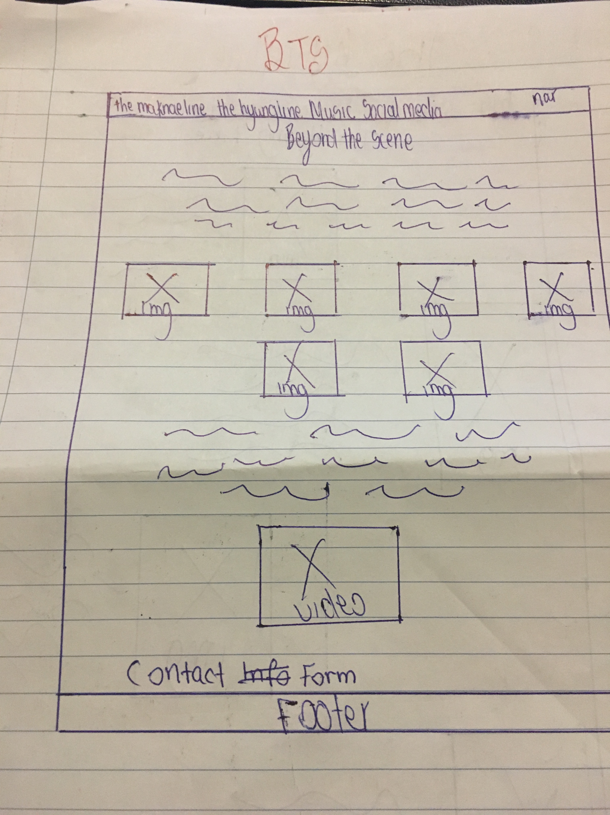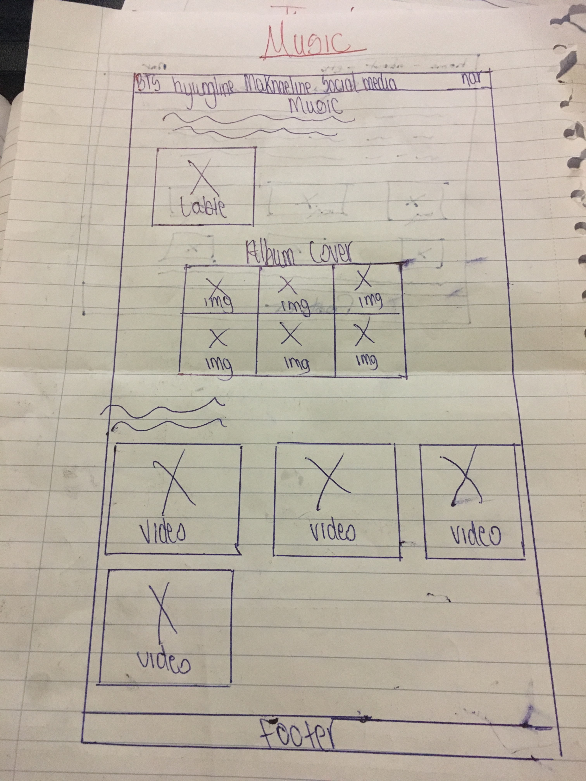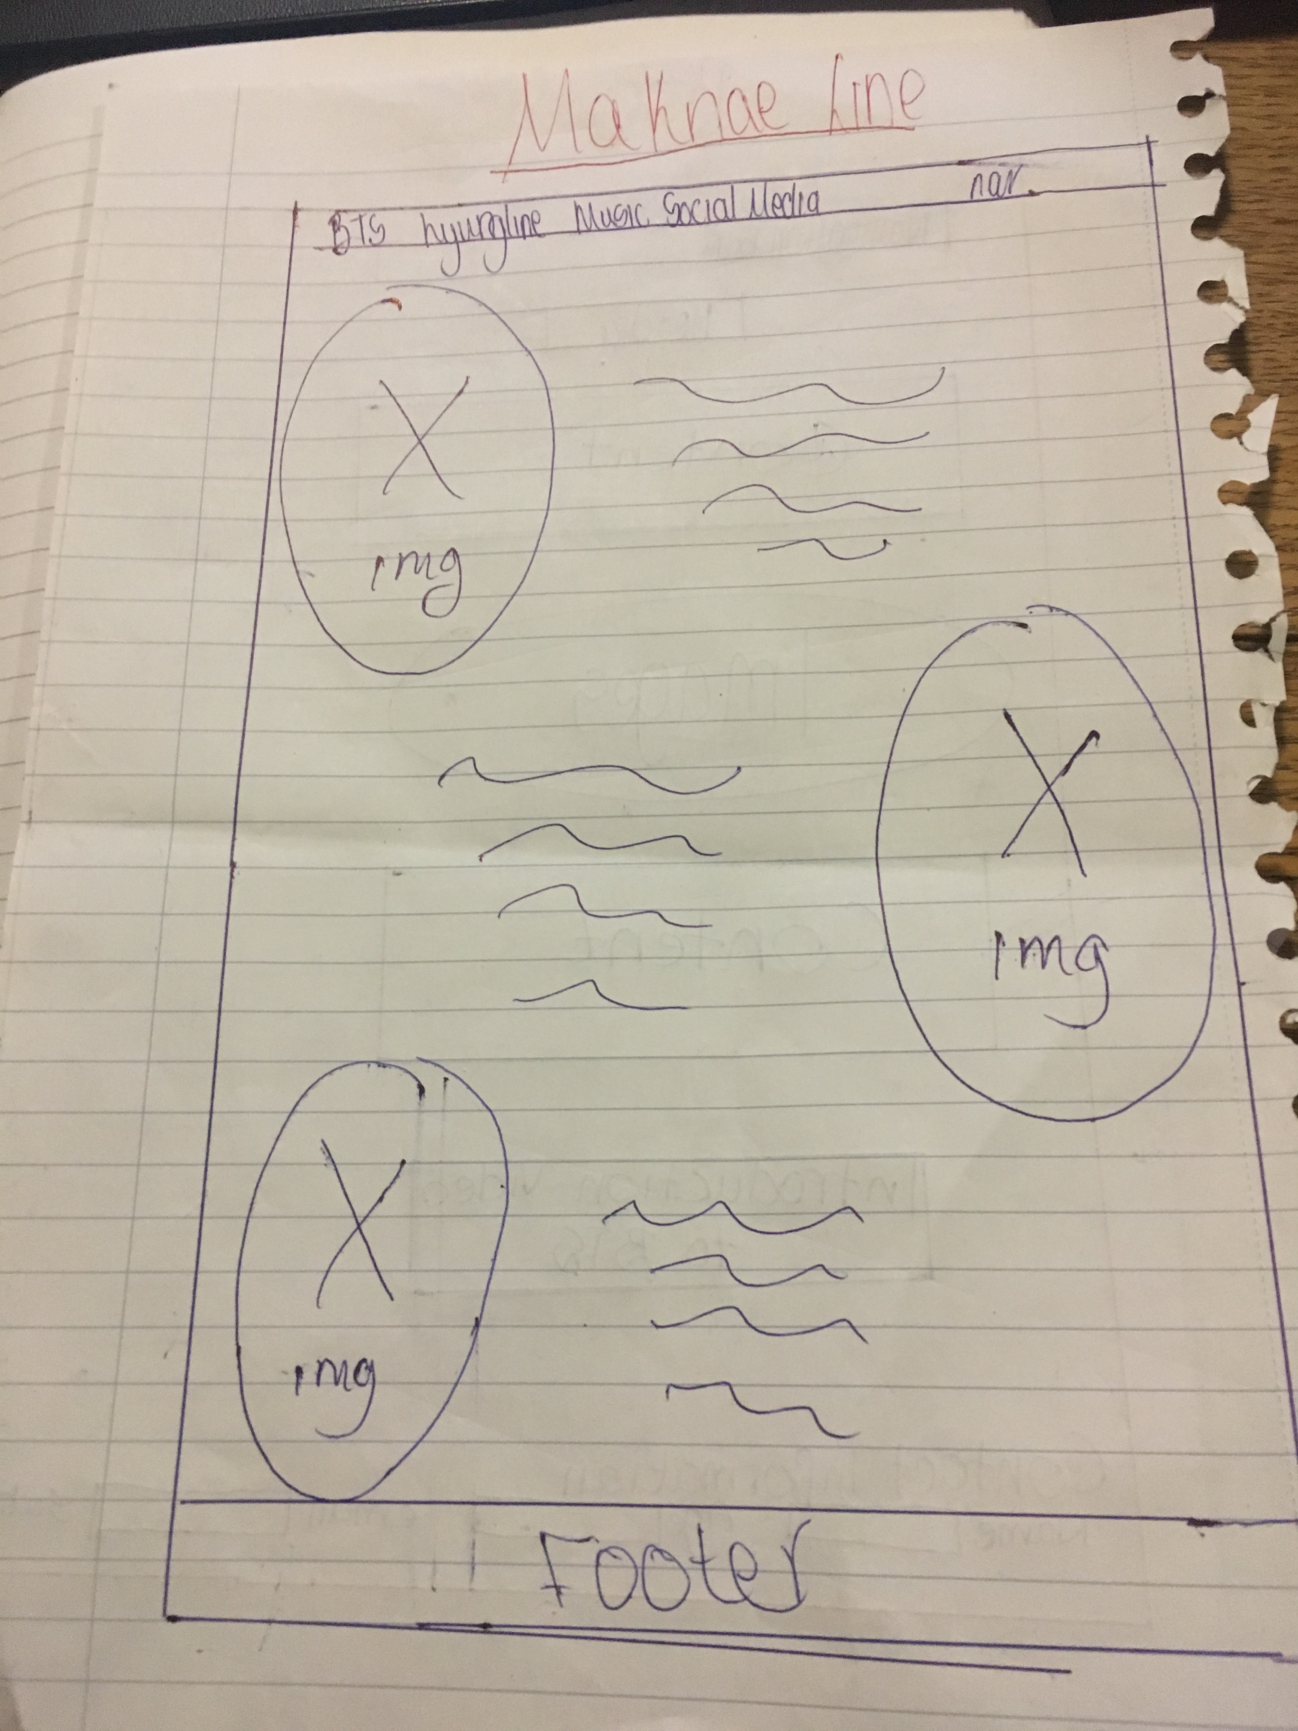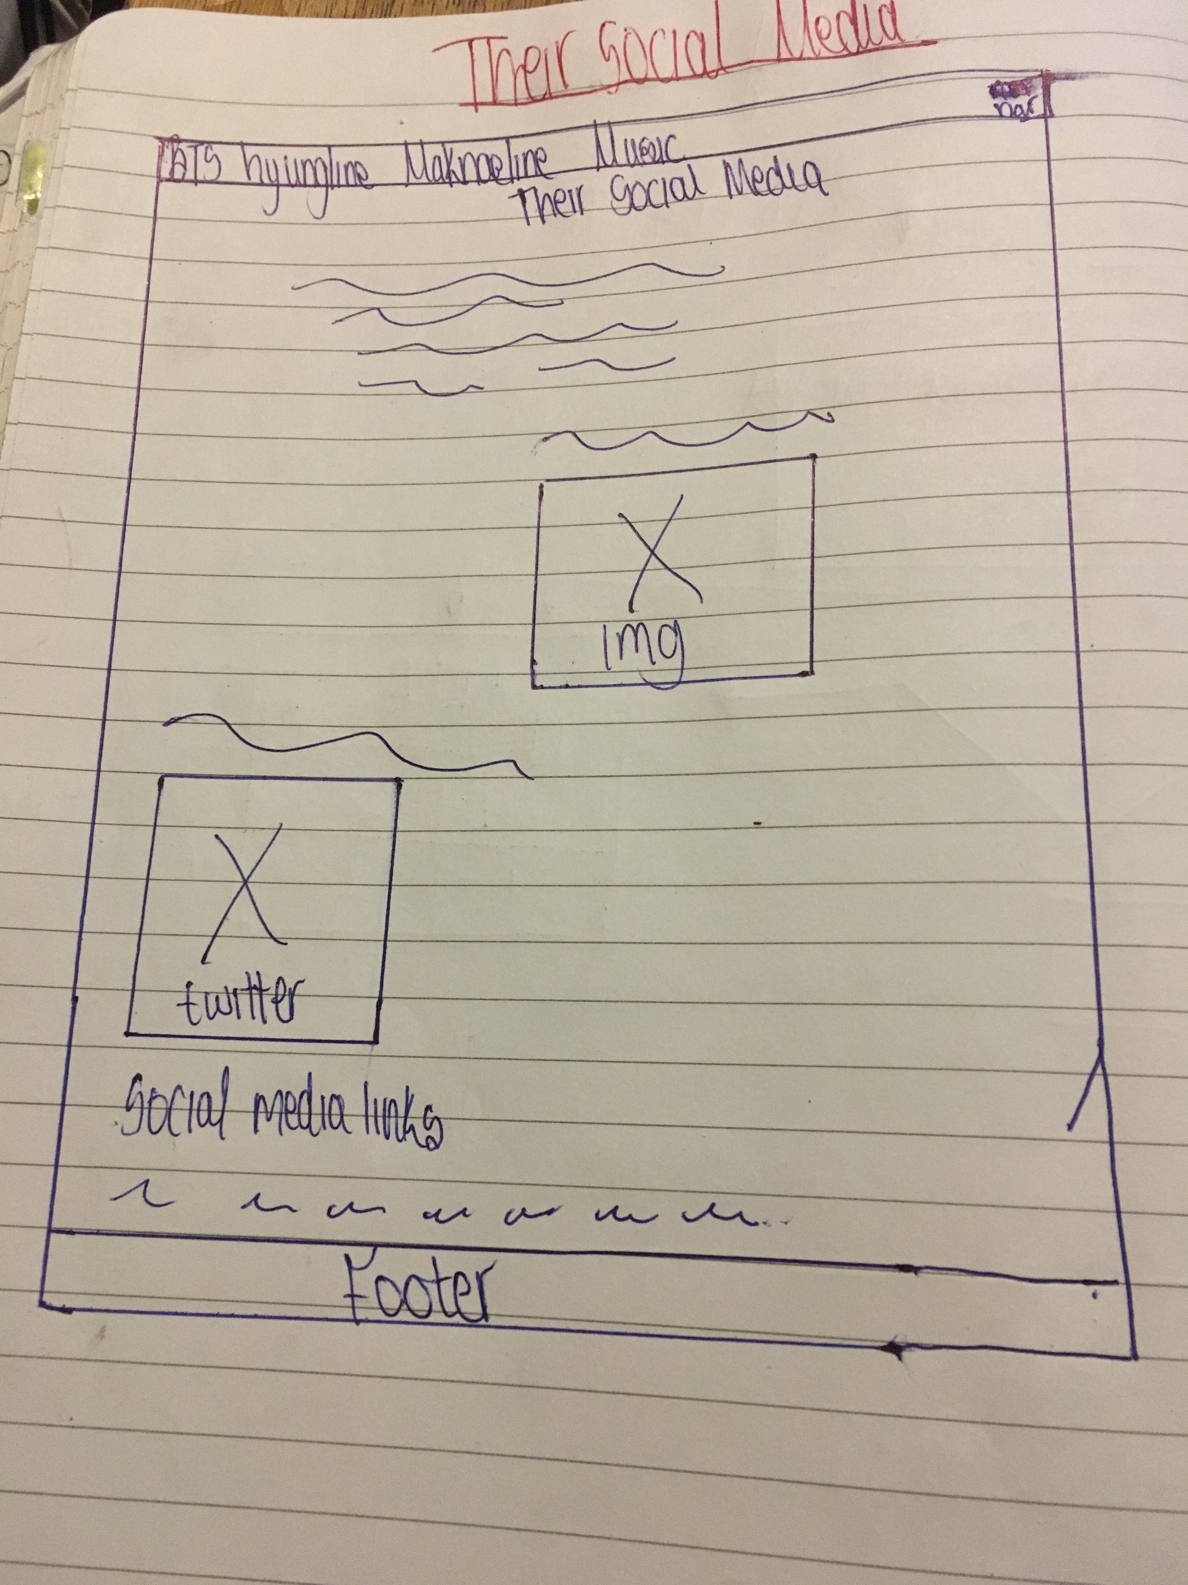

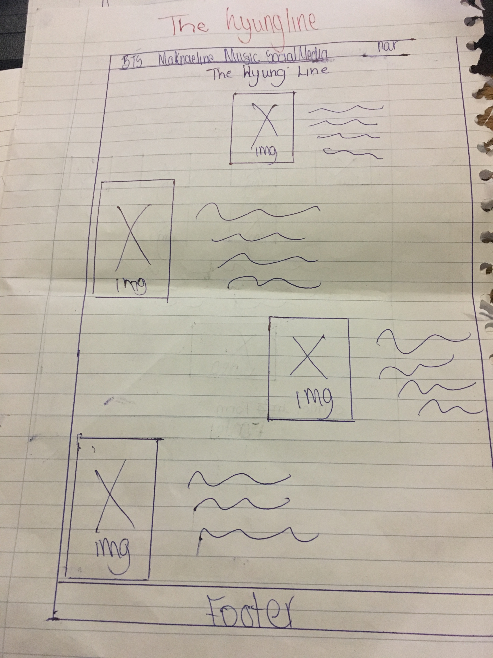

# Development Plan

The site was created using html, css and javascript as you know. I drew out, how I wanted my website to look like, then with the planning and drawing out, I used that as a guideline to help design my website.

I firstly did the css and the html first, because I knew that I could just follow the guidelines, if I was stuck and I didn’t know Javascript much, so I left it to the very end.

I had to also research other sites as I mentioned earlier because I wanted my website to at least look presentable to other people.

# Testing Plan

I used this website <https://validator.w3.org/> to help validate both my CSS and html. There were errors, so I had to fix the errors and I kept going back and forth to make sure that there were no errors.

Yes, my website is site Cross Browser Compatible

# Site Evaluation

I was able to evaluate my website by asking people who are bts fans and who are not bts fans, how they found my website. I asked them questions, such as: were they able to easily navigate the website and follow what was going on?

I also asked them on a scale of 1-10, would they be likely to visit my website again to find out more information about BTS?

Lastly, I asked them if they could change things what would they change?

With these questions, I was able to change by website to suit my targeted users and also people who may just want to check out my website.

# Deployment

I used the website 000webhost.com. It helped for free hosting. I created an account and I uploaded my index and my asset folder into a file. Then we clicked “I have already built my website”.

After we clicked that another page showed us, and this showed a link. I clicked on the link and then it showed my website.

I opened a word document, and I copied and pasted the link into the word document.

I save the document.

The techniques I used for Search Engine Optimisation are pasting my links up on google. I also searched keywords for my website and put the searched the name of my website up online.

I kept updating my website every time I deployed it.

# Appendices

